Screenshots:

Edit:

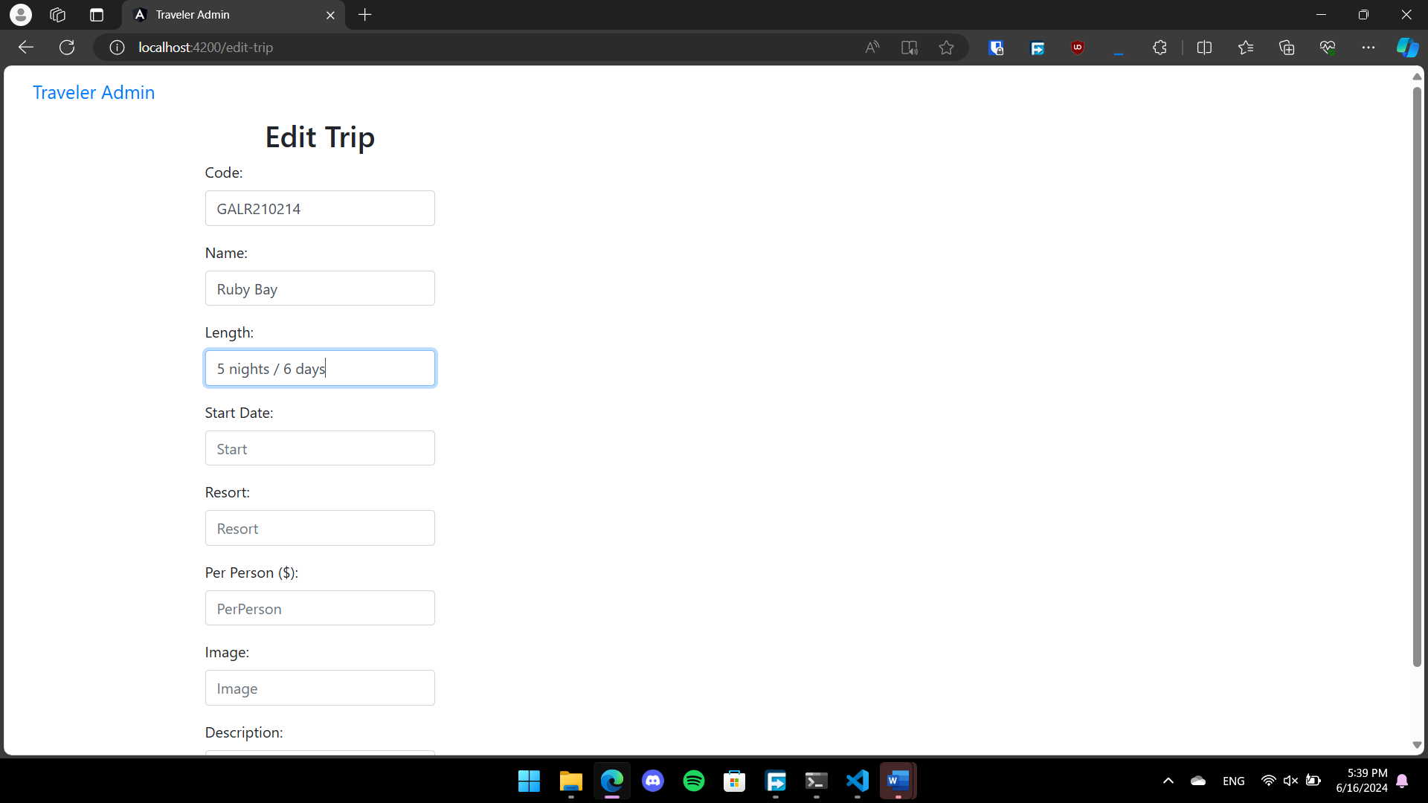

Update:

